MINUTES
BOARD OF TRUSTEES MEETING OCTOBER 12, 2016
WEDNESDAY, 4:15 P.M.

BOARD MEMBERS PRESENT: Jimmie McCamic, Chairman; Greg Marquart, Secretary/Treasurer; Leslie Nutting, Tony Werner, Robert M. Baker

BOARD MEMBERS ABSENT:

ALSO PRESENT: Dottie Thomas, Library Director; Amanda Berisford, Secretary/Bookkeeper; William Paras and Heidi Kossuth from Security National Trust Company

CALL TO ORDER: Mrs. McCamic called the meeting to order at 4:15 p.m. Mrs. McCamic changed the order of the meeting so that William Paras and Heidi Kossuth of Security National Trust Company could give their presentation on the Library's investment accounts.

SECURITY NATIONAL TRUST COMPANY ANNUAL PRESENTATION
Mr. Paras presented an annual report of the Ohio County Public Library's main investment account and the sub-account. He stated that both the main account and the sub-account have a balanced investment objective. Mr. Paras reviewed the Library's holdings of equity mutual funds within the main investment account. He asked the trustees if they anticipated the need for any cash disbursements to the Library from the investment accounts. Mr. Marquart answered that the Library shouldn't need any cash disbursements in the near future. Mr. Paras recommended spreading the risk and adding the money market proceeds to the fixed income holdings.

Mr. Baker arrived to the meeting at 4:21p.m. Mr. Paras stated that he was just about to begin reviewing the investment sub-account and asked Mr. Baker if he would like Mr. Paras to review the main investment account for him before proceeding. Mr. Baker said that was not necessary and thanked Mr. Paras for being willing to review it for him. Mr. Paras reviewed the Library's holdings of equity mutual funds within the investment sub-account. Mr. Paras recommended, again, that the trustees spread the risk and add the money market proceeds of the sub-account to the fixed income holdings. Mr. Paras said that the Library's current investments are quite favorable but he is recommending further diversification for liquidity and to keep internal costs low. He added that the short term numbers look good and the market has been resilient. Mr.
Marquart asked if Mr. Paras thought there would be any changes in the coming months with regard to interest rates. Mr. Paras answered that it is tough to call, however he did not anticipate a rapid or steep increase in interest rates. He added that the job market and unemployment statistics look good. Mr. Paras shared that there was some volatility in the market after Brexit (Great Britain's exit from the European Union), but it passed quickly. Mrs. Nutting asked if the upcoming presidential election could affect the stock market. Mr. Paras stated that there shouldn't be any negative reaction in the stock market because of the election. He said in most

cases political gridlock is good and there should not be a lot of volatility in the market. Mr. Baker asked if the negative interest rates in the global market could affect the stock market. Mr. Paras said that there should be little impact stateside, and that the negative interest rates were introduced overseas to stimulate the economies of countries with a large amount of debt.

Mrs. McCamic thanked both Mr. Paras and Ms. Kossuth for attending the meeting. Mr. Paras and Ms. Kossuth left the meeting at 4:31 p.m.

MINUTES: Mr. Marquart moved to approve the minutes of the September 14, 2016 board meeting. Mrs. Nutting seconded.

VOTE: Mrs. McCamic Mr. Marquart Mrs. Nutting Mr. Werner Mr. Baker
YES YES YES YES
ABSTAINED

FINANCIAL REPORT: Ms. Thomas distributed the September statement from the WesBanco Endowment Trust and the two September statements from the Library's investment accounts at Security National Trust Company.

Operating Account #2 Checking |  | $ 17,312.14
Payroll Account Checking |  | 0
Capital Money Market Savings |  | 371,593.88
Operating Money Market Savings |  | 708,569.97
Operating CD - Main Street Bank A |  | 104,670.02
Operating CD - Main Street Bank B |  | 105,171.67
Capital CD -First Choice #1 |  | 104,443.80
Operating CD -Progressive Bank |  | 215,358.95
Operating CD - United Bank A |  | 103,409.33
 | TOTAL | $ 1,730,529.76
Revenue received: September 2016
County Commission |  | $ 0
Board of Education |  | 65,057.00
State Basic Grants-in-aid |  | 0
Fines |  | 1,117.75
Photocopies |  | 598.20

Contributions |  | 3,095.56
Interest Earned |  | 145.04
Book Sale |  | 168.50
Out of State Patrons |  | 35.00
Other: Operating Supply CR -21.00 |  | 21.00
 | TOTAL | $ 70,238.05
OPERATING CONTRIBUTIONS
Wheeling Auto Club |  | $ 3,050.00
Anonymous |  | 45.56
 | TOTAL | $ 3,095.56
INVOICES
September 2016 Operating #2 Account |  | $ 54,680.82
September 2016 Transfer to Payroll |  | 35,915.01
September 2016 EFTPS Deposit |  | 18,015.64
September 2016 ACH Debit (Retirement) |  | 8,004.67
September 2016 EFT (WV State Tax) |  | 1,519.00
September 2016 Capital Account |  | 21,301.93
 | TOTAL | $ 139,43707
WARRANTS
September 2016 Operating #2 Account |  | $ 54,680.82
Warrants #28278 - #28337
September 2016 Transfer to Payroll |  | 35,915.01
September 2016 EFTPS Deposit |  | 18,015.64
September 2016 ACH Debit (Retirement) |  | 8,004.67
September 2016 EFT (WV State Tax) |  | 1,519.00
September 2016 Capital Account |  | 21,301.93
Warrants #538 - #539
 | TOTAL | $ 139,437.07
VERIFICATIONS
Total Operating Balances as of August 2016 |  | $ 773,829.99
+ September 2016 Revenue |  | 70,238.05
-September 2016 Expenditures |  | 139,437.07
 | SUBTOTAL | $ 704,630.97
Operating CD Main Street Bank A |  | 104,670.02
Operating CD Main Street Bank B |  | 105,171.67
Capital CD First Choice #1 |  | 104,443.80

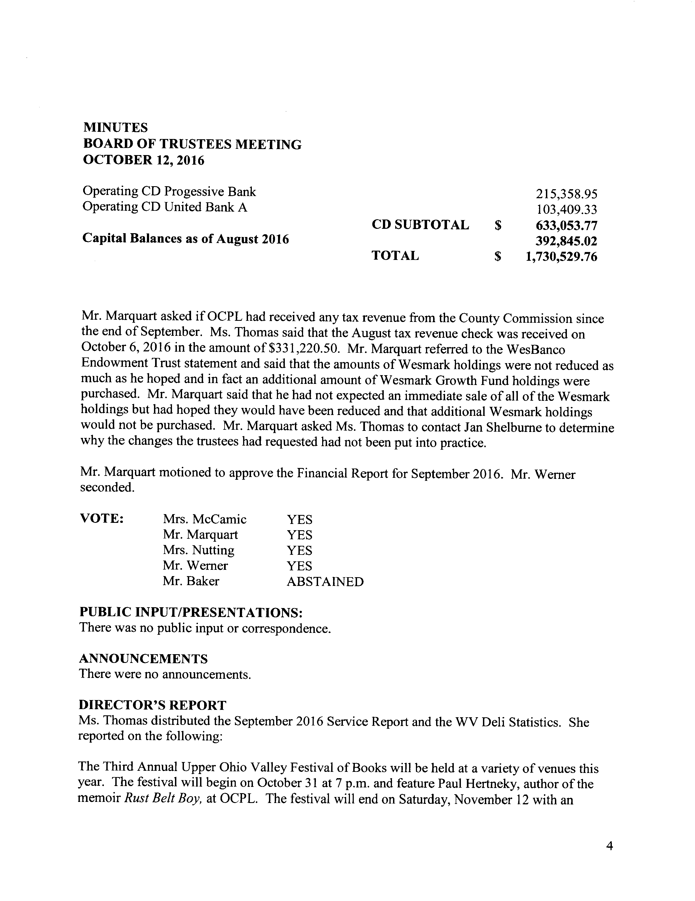

appearance by Jayne Anne Phillips, bestselling author and keynote speaker, at the Festival's finale which will also be held at the Library at 1 p.m.

The sixteenth course of People's University will begin on November 1 at 7 p.m. and will be a new edition of the very first People's University: "A History of Wheeling with David Javersak."

The Archives Department recently received a large donation from the family of William O'Leary of Elm Grove who passed away this past summer. The donation consists of numerous photographs and Wheeling area memorabilia that Mr. O'Leary had collected over the years.
Mr. Werner asked what era the photographs were taken. Ms. Thomas said that several appeared to be from the 1930s and Erin Rothenbeuhler, Reference Assistant, would have more information on the pictures. She said it would take Ms. Rothenbeuhler quite a lot of time to process, catalog and digitize such a large amount of archival material and make it available for the public.

The invoice for the replacement of roof area #3 has been received from Mansuetto Roofing for work performed to date. Ms. Thomas asked if the architects from M & G would need to sign off on the work performed before the bill should be paid. Mr. Marquart said that the architects would look over the roof and give their approval, but the roof material manufacturers also will inspect the completed job because the manufacturer guarantees the warranty.

The annual WVLA Fall Conference was held October 5 through October 7 and featured several good programs. Ms. Thomas, Lee Ann Cleary, Children's Specialist, and Julia Bachmann, Outreach Specialist, attended the conference that was held in Daniels, WV at The Resort at Glade Springs. Mr. Werner asked if the topic of dedicated funding was brought up again at this year's conference. Ms. Thomas said that WVLA is still working on getting a bill introduced to the West Virginia Legislature that would provide dedicated funding for all of West Virginia's public libraries. Mr. Marquart asked how Kanawha County Public Library was able to make up the difference when they lost their funding from the board of education. Ms. Thomas said that the school board was willing to run an excess levy for the annual funding the library needed. She said KCPL now receives more than their original funding from the Kanawha County Board of Education. Mr. Marquart said that the Kanawha County Public Library probably no longer needs a bill for dedicated funding to be passed. Ms. Thomas said that the Kanawha County Public Library is still in favor of introducing a bill for dedicated funding for the state's libraries. She added that excess levies must be put on the ballot every five years so the funding is not as stable as a dedicated funding law. Mr. Marquart asked if other struggling libraries had attempted to run excess levies to make up for their inadequate funding. Ms. Thomas said that some have and some were successful while others were not. She said this year Morgantown Public Library was made to compete with eight separate levies that were on the ballot, though they did get their levy passed. Mrs. Nutting asked if the eight separate levies in Morgantown meant that not all could pass. Ms. Thomas said that as long as the voters agreed to the levies they would all pass, but

it made it seem like a lot of taxes would need to be raised to pass all eight. Ms. Thomas said that funding for West Virginia libraries continues to be an issue and getting librarians in the state to agree on how they should be funded is also another issue. She said that different levels of funding based upon population seem to be the best course for satisfying the libraries' funding problems.

Ms. Thomas stated that she sent individual thank you notes to Ted Hess and Chuck Monfradi who are members of the Wheeling Auto Club Fund Committee in appreciation of the club's donation in September. Mr. Hess and Mr. Monfradi once served on OCPL's Board of Trustees. She said she also sent a thank you letter to the Community Foundation of the Ohio Valley.

Ms. Thomas handed out a copy of the Adult Programming and Archives Report and stated that there was a request from Sean Duffy, Adult Programming Coordinator, for some new display cases from the planned renovation project to house an exhibit on Wheeling's breweries. She said the request would be more fully explained during the renovation project part of the agenda.

Ms. Thomas stated that a representative, Dan Smith, from KPC Architectural Products, which specializes in moving stacks of books without unloading them, visited the Library and met with her and the architects from M & G to provide an evaluation. She said while the representative from KPC was here she asked him to check the stability of the oversize collection stacks. Ms. Thomas said that Mr. Smith said that the shelves seemed to be secure in his opinion, and that the shelves are designed to be flexible with some "give" to them. Ms. Thomas added that the weeding of the oversize collection is continuing to progress and should be completed within a few more weeks.

OLD BUSINESS

RENOVATION PROJECT FOR OCPL
Ms. Thomas referred back to Mr. Duffy's request for the immediate purchase of two of the new display cases, which are a part of the renovation project, for an archival display of items from local breweries. Mr. Duffy is asking that the trustees agree to purchase only two of the display cases, originally approved for purchase as part of the upcoming renovation project, to house the entire exhibit. Mrs. McCamic asked what the cost for only purchasing two display cases would be. Ms. Thomas said that Mr. Duffy had not provided a cost for the cases. Mr. Marquart asked if the lighting was built into the display cases. Ms. Thomas said that she was unsure whether the requested cases were lighted or not, but she said she could get that information from Mr. Duffy and e-mail the trustees with information about the lights and cost. Mrs. McCamic asked when the exhibit would be starting. Ms. Thomas said that a portion of the exhibit is currently on display and the rest would be displayed once the new display cases became available. Mr. Baker asked how many cases they need in total as there are only four left in stock. Ms. Thomas said that the

proposed new display area will make a large rectangle when the renovation project is complete; however, she said she did not remember the exact number of new cases that were proposed. Mr. Marquart said they would like to make sure that all of the display cases would match. Ms.
Thomas said that the display cases are frameless and should be easy to match. Mr. Werner asked if they should be all be purchased at the same time. Ms. Thomas said that storage space could be an issue as several items will need to be shifted to storage to accommodate the impending interior construction. Mr. Baker suggested contacting the company to inquire if a deposit could be made on the six display cases needed from Displays2Go and asking if the company could hold four of them and delay shipping until the Library was ready for them to make sure that all the cases would match. Mr. Marquart said that the display area will be the last area to be completed in the renovation project. Mr. Baker stated that if the company is unable to delay
shipping on the display cases, it may be possible to store the cases in the hallway at the bottom of the stairs near the 16th Street entrance. Mr. Baker asked what the total cost of the display area was. Mrs. McCamic said that the cost for the display area in the original renovation project budget also included the cost for wiring and installation of electrical outlets for the display cases. Mr. Marquart stated that he thought it was originally a $30,000 item. Mr. Baker asked if the trustees could make a motion to approve the purchase of the display cases without having the cost figures and asked if the 8% due to the architects would need to be paid on the cases since we are purchasing them directly or would we only be paying the 8% on the electrical work needed for the display cases. Ms. Thomas said that she would get the cost figures for the display cases and e-mail the trustees with the information. Mr. Marquart said he wanted to make sure we were covered and not overspend. Mrs. McCamic said that we may not want all the cases in the original plan. Mr. Baker motioned to approve the purchase of six display cases from Displays2Go as long as the total cost did not exceed $21,000. Mr. Marquart seconded.

VOTE: Mrs. McCamic Mr. Marquart Mrs. Nutting Mr. Werner Mr. Baker
YES YES YES YES YES

Ms. Thomas passed around a brochure from KPC Architectural Products who are based out of Lexington, KY. She said that KPC will be able to move the stacks without unloading them. Ms. Thomas said she also contacted a moving company that will unload, shift and reload the stacks
. The company is subcontracted to a moving company based in the D.C. area. She said that while she attended the WVLA Annual Conference she inquired of several colleagues and was unable to find another library in the state that had used a stack moving service. Ms. Thomas said that it was recommended to her by the Kanawha County Public Library Director that staff be present while the stacks are being moved to ensure that they are being returned to their proper locations. Mr. Marquart asked if KPC will come back with a proposal and meet with M & G to discuss

staging of the project. Ms. Thomas said she believed so. She said during the recent meeting of KPC with her and M&G representatives, she was informed that the entire Reference Collection will need to be relocated to allow enough room to house the Adult Fiction, Nonfiction and Large Type stacks during the various phases of the renovation project. Ms. Thomas said the current plan is to start with the Children's Department's ceiling and light replacement, as there will be no need to move the stacks there to accommodate the construction. She said that the second phase would include moving the stacks of the entire Adult Fiction & Non-Fiction collections forward into the public seating areas and into the area where the Reference Collection is currently housed. Ms. Thomas said that once the second phase is complete those stacks will be returned to their original places and the next phase will begin. This third phase will involve moving the Large Type Collection into the current Reference Area and the magazines off the walls into whatever space is best suited to that collection. She said the final phase on the main floor will involve the Reference, YA, and public access computer areas. Mr. Werner asked if all of the moving would happen after the Library's normal operating hours. Ms. Thomas said that may be a possibility but as much of the project as possible will occur with the Library open, but it may be necessary to close at times to accommodate the workers.

Ms. Thomas stated that an issue arose when Johnson Boiler began to remove the fence surrounding the chiller on the roof. She said a conduit pipe covering the wiring for an outlet on the fence broke off at roof level. Ms. Thomas said that it was necessary to remove ceiling tiles over the public seating area in front of the Nonfiction Collection to access and repair the conduit pipe. She said while Johnson Boiler was in the process of making the repair they found that some of the ductwork above the ceiling tiles had become separated. Mr. Marquart said that the existing ductwork was hung from the roof deck with screws, instead of being attached to brackets in the bar joists, which is no longer allowed by today's standards. Mr. Marquart said that the ductwork is not metal and is a fiberglass duct board which was probably selected to reduce the amount of noise coming from the ductwork on the main floor. Ms. Thomas passed out a proposal from Bob Neidhart of Johnson Boiler detailing the ductwork separations that were found as well as a quote for his recommended repairs. Ms. Thomas said that the architects from M & G were able to lift the ceiling tiles and inspect the ductwork in a spot in the Technical Services area. She said they said the ductwork in that area is also the fiberboard and is hung like the ductwork in the public seating area. Mr. Werner asked if the ductwork was fastened in the same manner as the separated ductwork. Mr. Marquart said that it was, however once the new ceiling is installed on the main floor we will be able to make repairs as needed without replacing all of the ductwork, which is currently not in the budget. Mr. Werner asked if the warranty for the new roof would be affected by the ductwork fasteners that were attached to the roof deck.
Mr. Marquart said that it shouldn't affect the warranty, if we see an issue that may have caused a leak it may be necessary to add brackets to secure the ductwork and to prevent movement. Mr. Baker said it may be necessary to use a slide assembly and tape over the joints. Ms. Thomas said that Dan Grant, architect from M & G, inspected the ductwork and copied the product number to

check it for the possibility of containing asbestos. Mr. Marquart said that he spoke with Eric Matyskiela and Dan Grant, from M & G, and they recommended only making repairs as necessary as the project progresses. Mr. Baker said that he understands the section of ductwork that has dropped may require more work, however he feels that the quote from Johnson Boiler Works for the current ductwork repairs seems quite high. Mrs. McCamic stated to hold off on replacing all the ductwork recommended by Johnson Boiler Works.

Ms. Thomas stated that another special committee meeting with the architects will be held next week on October 19, 2016. Mr. Marquart asked if the previous minutes from the last special committee meeting were sent to the trustees. Ms. Thomas said that she would double check that the most recent renovation project minutes had been sent. Mrs. McCamic stated that the special committee had met with M & G on September 28. She said that they provided a revised overall project budget including Mr. Baker's recommendation that ceramic tile be installed instead of the FRP panels in the main floor restrooms. Mr. Marquart said that the new overall budget is still close in number to the original budget and may even be a little bit less. Mr. Baker stated that he abstained from the vote to approve the Minutes at today's meeting because the changes to the restroom walls replacing the recommended FRP panels with ceramic tile did not happen until after last month's board meeting and yet the change is detailed in the Minutes.

Ms. Thomas stated that after meeting with KPC and M &G earlier today, she and Amy Kastigar, OCPL's Reference Librarian, will immediately begin weeding the Reference Collection to make room to move those stacks. Mr. Baker asked if the flooded libraries were still interested in receiving the discarded reference materials and if they would be willing to pick them up. Ms.
Thomas said that she was planning on putting a list out on the WVLA listserv for all the libraries in West Virginia to see, however, she said it may be necessary to put a deadline on the amount of time libraries would have to pick the materials up due to the upcoming renovations. Ms. Thomas said that the Reference Collection needs to be reduced from seven shelves to three. She also said that when KPC comes in to move the stacks it may be necessary for the staff to help push the shelves from area to area. Mr. Marquart said that KPC may be able to "rent" help from the General Contractor to help move the stacks.

WESBANCO ENDOWMENT TRUST UPDATE
Ms. Thomas said that she e-mailed Jan Shelburne, from Wesbanco, detailing the changes the trustees desired made in investment strategy with the Endowment Trust. She said she had not yet heard back from Ms. Shelburne. Mr. Marquart said that they had not expected an additional
$50,000 of WesMark purchases to be made in the last half of September after meeting with the board on September 14 when the board made clear they preferred to reduce investment in WesMark funds. Ms. Thomas said she would contact Ms. Shelburne to inquire why this additional purchase was made and to again check on the progress of the changes the trustees requested.

EXECUTIVE SESSION
Mr. Marquart moved to enter Executive Session at 5:46 p.m. Mr. Werner seconded.

VOTE: Mrs. McCamic Mr. Marquart Mrs. Nutting Mr. Werner Mr. Baker
YES YES YES YES YES

Mr. Werner motioned to exit Executive Session at 6:24 p.m. Mr. Baker seconded.

VOTE: Mrs. McCamic Mr. Marquart Mrs. Nutting Mr. Werner Mr. Baker
YES YES YES YES YES

There being no further business, Mr. Werner moved to adjourn the meeting at 6:25 p.m. Mr. Marquart seconded.

VOTE: Mrs. McCamic Mr. Marquart Mrs. Nutting Mr. Werner Mr. Baker
YES YES YES YES YES

Respectfully submitted,

Amanda Berisford Secretary/Bookkeeper

